廣都工程行 04-25358429 0932-518699 and.and@seed.net.tw http://epoxy.web66.com.tw

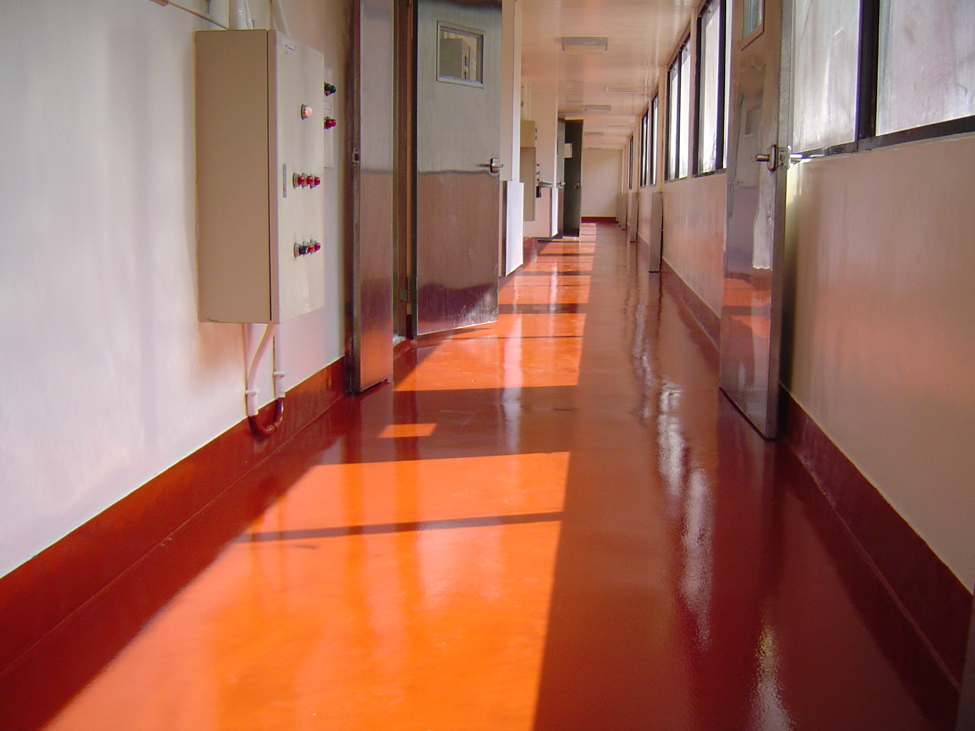
i-KRETE HD 產品數據

產品說明
i-KRETE HD是可以自行接著，不必塗佈底層接著劑及面層密
封劑的五組份型水性聚胺酯鏝刀施工型砂漿地坪系統，
i-KRETE HD的標準施工厚度是6 - 9 mm，i-KRETE HD材料硬
化後的砂漿層會變成非常堅硬，不僅可以耐高度衝擊抵抗，而
且具有絕佳的抵抗磨耗、磨損、溫度、化學品…等效能。

用途
i-KRETE HD是專門設計使用於食品及飲料產業，本地坪系統
除了可以提供超強的耐衝擊、磨耗、化學品洩漏噴灑…等
抵抗效能外，而且完成後的i-KRETE HD地坪可以抵抗每日因
清潔維護工作(熱水沖洗)所造成的急速冷熱衝擊或冷熱循環衝擊。i-KRETE HD材料不僅可以使用於新建的地坪工程，而且
是舊地坪的改修工程的最適當使用材料(快速硬化)。

產品優點
- 耐衝擊。
- 自行密封，不需塗佈面層塗料。
- 無縫衛生表面，沒有可供污穢物藏匿及細菌滋生的縫隙。
- 耐溫度抵抗：-45 到120℃。
- 能夠抵抗急速冷熱衝擊或冷熱循環衝擊。
- 絕佳的耐化學品滲漏噴灑抵抗。
- 容易清潔，低維護需求。
- 高耐磨耗抵抗。
- 施工期間只會產生低臭味。
- 止滑表面。

標準顏色
灰色 棕色 彩綠

黃色 乳黃

特別色需要有較長的訂貨時間及最低訂購數量。

i-KRETE HD PRODUCT DATA

Product Description
i-KRETE HD is a self priming, five component troweled
polyurethane screed system with self-sealing finish.
The standard thickness for i-KRETE HD is a nominal 6-9 mm.
i-KRETE HD cures to an extremely hard, high impact
resistance mortar which exhibits excellent abrasion, wear,
temperature and chemical resistance.

Uses
i-KRETE HD is formulated specifically for the food and
beverage industry. To provide a superior impact and
abrasion resistance with good chemical resistance and hard
wearing floor finish i-KRETE HD can be used as a protective
overlay on new floor or to repair damaged floor.

Benefits
• Impact resistance.
• Self sealing
• Seamless & hygienic finish, no crevices where dirt
and bacteria can dwell.
• Temperature resistant -45℃ to 120℃
• Steam Cleanable
• Excellence chemical resistance
• Easy to clean, low maintenance requirement.
• High abrasion resistance
• Low odor during installation
• Positive Resistance

Standard ColorCharts

Grey Red Green

Yellow Cream

Color matching available with sufficient lead time and minimum order
requirement.

Substrate
基底
i-KRETE HD可施做於混凝土、木質、磁磚或鐵質材料的表面上。不建議施做於柏油或油漆材料的表面上，此類材料必須完全鏟除後才能施做i-KRETE HD。

選用品
圓形衛生踢腳
提供牆面與地坪接縫間的完全密封，可使用i-KRETE Coving Mortar (踢腳用砂漿材料)及i-KRETE Primer (無溶劑型接著密封底塗劑)。

包裝
i-KRETE HD是以小包裝組合方式供應，每組材料包含：
A部(Polyol)、B部(Isocyanate)、C1部(細骨料)、C2部(色粉)及D部(粗骨料)。

標準用量
每組i-KRETE HD材料大約可施做下列面積：
厚度6 mm：2.50㎡。
厚度8 mm：1.87㎡。
厚度9 mm：1.66㎡。

素地表面前處理
適當的基底表面預處理對於確保足夠的接著力是非常重要的，
基底表面必須乾燥而且無油脂、脂肪、油污或其他污染物。基
底表面必須使用噴砂機、刨除機、鑽石磨盤研磨…等方式預先
處理，處理後的基底表面必須有和砂紙一樣的止滑表面。

接著底塗
i-KRETE HD材料可以自行接著，不必塗佈底層接著劑。但是
非常粗糙的基底表面可以先均勻塗佈i-KRETE Primer (無溶劑型環氧樹脂接著密封底塗劑)，等接著密封底塗劑表面硬化後，才能施做i-KRETE HD材料。

攪拌混合
- 先將A部及B部倒入攪拌桶內，使用螺旋形攪拌葉片的攪拌機高速攪拌30秒。
- 再將C2部(色粉)及C1部(細骨料)倒入攪伴桶內，高速攪拌30秒，然後再加入D部(粗骨料)再高速攪拌30秒，在直到骨料完全濕透為止。

材料可施做時間
攪伴後的i-KRETE HD材料硬化時間非常快，可施做時間大約只有7分鐘(30℃)，可施做時間的長短會依施工現場溫度而變動。

施工
- 材料經攪拌後，必須立即施做。
- 使用放料機將攪拌後的材料均勻鋪於基底地坪上。
- 使用手鏝鋼刀，用力將材料壓下並鏝平。
- 使用中毛滾筒消除鏝刀痕跡並使表面材料的顏色一致。
- 詳細施工內容，請參考i-KRETE HD施工說明書。
i-KRETE HD is suitable for application over concrete, wood,
tile or metal. Not recommended on asphalt o painted
surface.

System Options
Cove Base
To provide for an integral seal at the joint between the
floor and wall. Coving can be formed with i-KRETE Coving
Mortar in conjunction with i-KRETE Primer.

Packaging
i-KRETE HD is packaged in 30 kgs./set, consist of:
Part A and Part B
Part C1 and Part C2 (Easily identifiable Pigment Pack)
Part D (Aggregate)

Storage & Coverage
Each set of i-KRETE HD will cover approximately
as follow:
• 2.50 sq.m. for thickness 6 mm.
• 1.87 sq.m. for thickness 8 mm.
• 1.66 sq.m. for thickness 9 mm.

Substrate preparation
Proper preparation is critical to ensure an adequate
bond. The substrate must be dry and free of grease,
fats, oil and laitance. Totally enclosed shot blasting or
scarification. The surface must be show open textured
surface like a sand paper texture for mechanical
bonding.

Priming
i-KRETE HD is self-priming system. For porous substrate
use i-KRETE Primer. The primer system must be cure to
a tack-free state before applying i-KRETE HD

Mixing
• Add Part A and Part B into mixing pail. Mixing
with the blender with helical spinner for 30
seconds.
• Add Part C2 (Pigment Pack) and Part C1 into
mixing pail and mix for 30 seconds then add
Part D (Aggregate) Allow the contents to mix
until aggregate is thoroughly “wet out” for 30
seconds.
• Compact and smooth the mortar using a hand
trowel followed by rolling to bring up and
saturate the resin. Allow to cure overnight.

Pot life
i-KRETE HD has working time of approximately 7 minutes
at 30℃ The working time will vary depending on
temperature.

Application
• Material must be use immediately after mixing.
• Use screed box to distribute the mixed onto thefloor.
• Use steel finishing trowels to compact and smooth
the surface of the material to the required.
• Use medium nap roller for make the uniform color
appearance.

Hardening Time
硬化時間(30℃)
- 完工6小時後可開放步行交通。
- 完工24小時後可抵抗一般工業用化學品的滲漏噴灑及開放重度交通設備。

貯藏期限
將未開封的材料儲存於溫度25-35℃的乾燥場所，避免讓材料過熱或結凍，未開封材料的有效使用壽命為12個月。

設備及工具清潔
完工後立即使用甲苯或二甲苯清潔施工及設備工具，當使用清潔用有機溶劑時，應注意火災及健康的預防。

重要事項
如果預期有長時間中斷施工(例如：午餐休息時間)的情況發生時，必須清潔所有的施工設備及工具。此清潔動作可以防止先前施做材料的硬化顆粒污染到後來施做的新材料，此舊材料的硬化顆粒會嚴重影響i-KRETE HD地坪完成面的品質。

注意事項
避免讓A部及B部的液體材料直接接觸到身體，因為它們可能會引起皮膚或眼睛的敏感。萬一發生此事時，立即用清水沖洗至少15分鐘，如發生皮膚或眼睛敏感時，應立即到醫院接受治療。施工人員應戴上不會透水的橡膠手套，以保護雙手不會接觸到液體材料。施工後、飲食或抽煙前，應先用肥皂及清水清洗雙手。

物理∕化學特性
耐壓強度 (ASTM C-579) ：75 N/mm² 在7天以後

抗拉強度(ASTM C-307) ：15 N/mm²

彎曲強度(ASTM C-580) ：20 N/mm²

硬度(ASTM C-2240/Shore D 側硬度器)： 80-84

接合強度(ASTM C-4541) > 2.5 MPa(100% 混凝土脫落)

衝擊阻力(ASTM C-4226) >160英吋∕磅。

吸水性(ASTM C-413) 0%

防滑抵抗(擺錘止滑測試) 乾燥 100
潮濕 40
耐溫抵抗：
• 6㎜. -20℃ ~100℃
• 8㎜. -40℃~120℃
• 9㎜. -45℃ ~120℃

At 30℃ allow:
• 8 hours for foot traffic.
• 24 hours for common industrial spillages and
heavy traffic.

Shelf Life
Store unopened in dry conditions at 25-35℃ Avoid excessive
heat, moisture and do not freeze. The shelf life is 12 months
in original, unopened container.

Cleaning up
Clean up mixing and application equipment immediately
after use. Use toluene or xylene. Observe all fire and
health precautions when handling or storing solvent.

Important
If any unusually long delay should arise, such as a break
for lunch, it will be necessary to completely clean all mixing
paddles and pails before ceasing operation. This is
extremely important. Doing this will prevent the later
contamination of the new batches of i-KRETE HD with
particles of partially cured material when the mixing
operation starts up again after the break. The presence of
such particles would seriously affect the troweling and
finishing of the floor.

Caution
Avoid contact with Part A and B as they may cause skin
and/or eye irritation. In case of contact, immediately flush
area with copious amounts of clean water for at least 15
minutes. Seek medical attention. Applicators should
cover hands with impervious gloves. Wash hands
thoroughly with soap and water after use, and before
eating, smoking, etc.

Physical/chemical characteristics
Compressive Strength 75 N/mm2 after 7 days
(ASTM C-579)
Tensile Strength 15 N/mm2
(ASTM C-307)
Flexural Strength 20 N/mm2
(ASTM C-580)
Hardness 80-84
(ASTM C-2240/Shore D Durometer)
Bond strength > 2.5 MPa
(ASTM C-4541) (100% Concrete failure)
Impact resistance >160 in./lbs.
(ASTM C-4226)
Water absorption 0%
(ASTM C-413)
Slip Resistance Dry 100
(Pendulum Slip Test) Wet 40
Temperature Resistance:
• 6 mm. -20℃ to 100℃
• 8 mm. -40℃ to 120℃
• 9 mm. -45℃ to 120℃

