E27 Bulbs 11W LED SPOTLIGHT
Mode TYPE: JCA70CT-11WXR-E27
Product Specifications
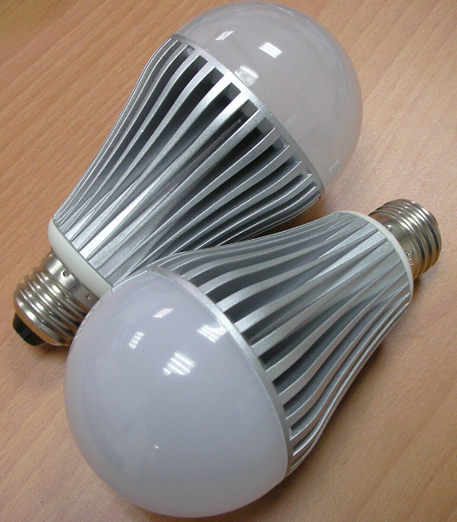

Features:
- LED Photo source : CREE CHIP LED inside
- Bulb Type: Socket drop-n replacement halogen lamp
- Base Type: E26
- Beam Angle: 120 Degrees.
- Total Power: 11.0 Watt.
- Light Output: 850~1000Lm
- Color Temp: 2500K,2900K,4300K,5000K,6300K
- Estimated Lifespan: 20,000 hours
- Cool light, No UN or IR Radiation.
- CE & RoHS & LVD & EMC approvals.
- Optimized Thermal Management: Body temperature ＜65℃(Ta=25℃)
- Switching Power: high efficiency and constant current designs.
- Net Weight: 180g

Typical Applications:
- Landscape accent/Sport lighting
- Architectural lighting
- Display case accent
- Artwork lighting
- Mood lighting/General lighting
- Amusement park accent

Materials as Follows:
- Aluminum Cup: Skived heat sink.
- Optical Lens: Optical grade PC Lens
- LED Light Source: 0.5W X 20pcs
- Light Base: PC
- Power module: Switching Mode
- Connect Pin: Cu Plating Sn

Electrical Specifications:
- Operation Supply range: AC 100~240V (50Hz/60Hz)
- Input current: 110 mA
- Total power dissipation: 11W
- LED forward current: 300 mA
- Operation Specifications: -40℃ ~ +75℃
- Storage Specifications: -40℃ ~ +85℃

