LED Tube

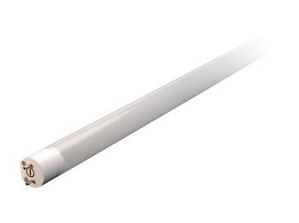
T8 tube (YUL-19)
Base G13
Weight 395g
Working Voltage 85~265V AC
Operating Temp -20~40℃
Lifespan 50000 hours
Warranty 3Years Limited
Driver Inside
LM 2200lm(3000K/4000K/6500K)
RA 80
