

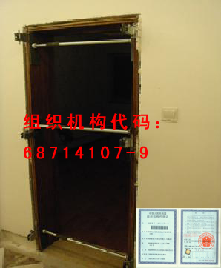

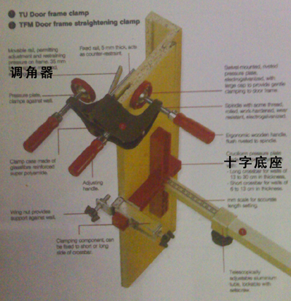

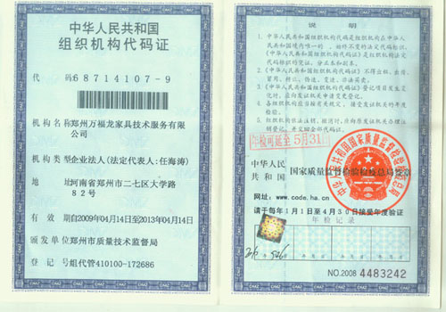

D1 INTERNATIONAL ROAD

A little tool can change the world.
Setting the Interior Wood-Doors.
Yes. D1 just the tool for this.

D1- DRAGON 1ST TYPE

Function: setting the inside wooden-doors

Size: Length-620MM~1000MM pole
All of them can be connected freely. So D1 should be 620MM~ ∝.

Material: PVC & METAL

Frame: 1 connector [PVC] & 2 poles [METAL]

Weight: 300 g/piece

Specifications： 3 functions
1st -for the design about adjust poles’ Stress-Structure-Material analysis
2nd -for the design about adjusting the distance door to floor exactly
3rd -for the design of Six-Direction rule, it used on punching the lock

Price: 4 kinds (FOB & no Freight)
A:1st Order-20 pieces 5 dollars/piece 100 dollars 3 functions(all)
B:1st Order-10 pieces 7 dollars/piece 70 dollars 1 function (1st )
C:1st Order-5 pieces 10 dollars/piece 50 dollars 1 function (1st )
D:1st Order-1 piece 30 dollars/piece 30 dollars 1 function (1st )
A customers can be D1 local agent.

EMS: CHINA——USA 7~15 days 20 pieces need 80 dollars
Other kinds will low.
Advice local price is 10 dollars/piece.
ATTENTION:
- You should know the setting wood-doors’ way of China.
For example, the wood wedge can be used for adjusting the space between the wall and the sash.(Or you have professional clamp)
- The product’s price is 1/20 of the germany product.
- We have 19 provinces’ customers in China.
- You, can be our trader too. UNION-ONLINE

TRADE WAY:
PPT——Point-Port-Trader.
One point, One port, One trader. (We just find one trader in one city)

REMITTANCE WAY: [VISA]
BANK NAME: INDUSTRIAL AND COMMERCIAL BANK OF CHINA HENAN BRANCH
SWIFT CODE: ICBKCNBJHEN
BANK ADDRESS: INDUSTRIAL AND COMMERCIAL BANK OF CHINA HENAN ZHENGZHOU HUANGHE BRANCH
USER NAME: REN HAI TAO
ACCOUNTS: 4270 2000 5821 9065 （CNY/USD）
Visa card and the number is 4270 2000 5821 9065.

CONNECTION:
COMPANY REGISTER ADDRESS: Daxue Road 82,Zhengzhou Henan P.R.China 450052
★★★TELEPHONE: +86-371-60930097 (My english just so so.)
★★MOBILE: +8613137116605 (We can send the mobile notes for connectting too.)
- E-MAIL: 836350297@qq.com（We’d better use email for connectting first.）
- MSN: kingbird2012@hotmail.com (Best one)
WEB: www.wonderful-dragon.cn (Union-Online Trader World.)
Sure we will contact easily if you have friends in China.

REMARK:
·COMPANY CODE: 68714107-9 (It can be searched in chinese goverment web)
·When we get the money, we email to you first and send the products.

D1 must get into the international market. (It’s his mission.)

Designed by Zhengzhou Wonderful-dragon Furniture Technology Co., Ltd.

D1 PRICE IN MONEY KINDS

MONEY KINDS | PRICE/PIECE | 1ST BUY（20 PIECE） | REMARK
USD | 5 | 100 | EMS: CHINA-AMERICA(7 DAYS) +80 dollars
HKD | 40 | 800
PTA | 40 | 800
TWD | 150 | 3000
JPY | 400 | 8000
EUR | 4 | 80
GBP | 3 | 60
CHF | 5 | 100
CAD | 5 | 100
AUD | 5 | 100
SGD | 7 | 140
DKK | 30 | 600
NOK | 30 | 600
SEK | 30 | 600
MOP | 40 | 800
NZD | 7 | 140
KRW | 6000 | 120000
RUB | 150 | 3000
MYR | 15 | 300
ZAR | 40 | 800
PHP | 200 | 4000
THB | 150 | 3000
TWD | 150 | 3000

