Ethernet Thermometer,2 channels Dx sensors, Multipoint-Temp system
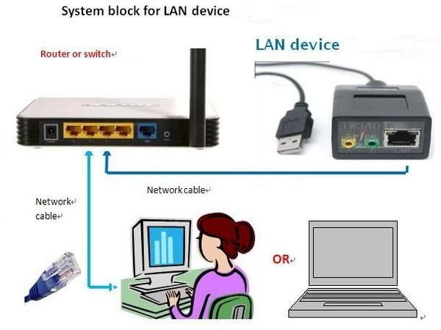
1. Features
(1) Equipment support the standard 1-Wire agreement, support 1-Wire digital temperature sensor DS18B20 (Dx sensor), temperature resolution 0.0625 degree;
support IIC digital temperature sensor FM75 (Tx sensor). But, both cannot be used at the same time.
(2). Equipment can connect up 12 Dx sensors, Or connect up 8 of Tx probe .
(3). Software support Windows series, and support real-time temperature display, log records, curve shows, MSN remote view data, E-mail alarm etc. Function
(4). Equipment support UDP, in which the TCP protocol, either as a server but also as a client. Server maximum can support five units (client) at the same time. UDP only support the client
(5). Equipment LAN module can be configured
(6). Equipment support reset function, when IP changes or forget the IP, you can long press "Preset keys” 3 s can be restored to the default value
(7) LAN series product can be reached WEB remote view data through the PCsensor.us . Welcome users to free register
The default LAN basic configuration
(1) device ipaddress:192.168.1.188
(2) device netmask:255.255.255.0
(3) device gateway:192.168.1.2
(4) host ipaddress:192.168.1.16
(5) connection type: tcp
(6) host port:16000
The following is cannot a configuration items:
As a TCP server, equipment listening port is 5200.
As a TCP client, equipment local port is 40000.
As UDP client, equipment local port is 30000.
2. Electronic Parameters
(1). The rated voltage: + 5 V
(2). Rated current: about 130mA
(3). Rated power: 550 mW
(4) Temperature Accuracy: Tx probe :+/-1.5degrees Celsius ;
Dx probe : ±0.5degrees Celsius
(5). 1-Wire line length: (theory) 50 m, (suggest) < 5 m
(6). The probe number: (the biggest quantities) 8 pcs (Dx probe)
(the biggest quantities) 8 pcs (Tx probe)
3. Operating Instructions
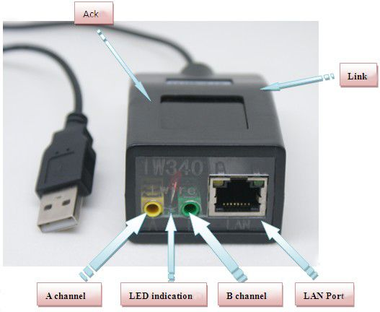
3.1 . Operation steps
3.1.1 First the 5 m extension cable, Yellow converter, sensors connected and inserted to 1W340A yellow or green any two of the interface, connect network Cable .please ensure that connect normal.
3.1.2 Turn on the power .LAN port of LINK light blink, flashing that said ACK network connection to normal. If not, please check your network is normal or not. Red LED the unusual light flashing, said equipment find probe, and reading temperature. If not, please check your probes whether good connection, you can connect well probe again after restart your device.
3.1.3 Open software, if your IP section is not our default 192.168.1. XXX section, please manually add own IP section, (see picture 3-3-1 and 3-3-2)
3.14 Add IP successful, and then open the software can find equipment if still can't find your IP that prove setting wrong or subnet mask setting wrong. When you find device, then you can modify the device's IP.
3.15At this time, the normal work equipment, if temperature display “error” , that says the probe didn't insert or contact undesirable, please adjust the probe .
3.2 Frequently Questions and resolution
1 Q: why Equipment connected not succeeds ?
A: Checking Network Cable connected and Checking your LAN IP segment. If continue does not work, Please press the reset button, IP restore the factory settings.
2 Q: why the device cannot find the probe?
A: whether it is operational problem? Please ensure that all equipment with a good, then, connect the power, the device will immediately search the probe. So, please check whether the probe is connected short circuit or poor contact. Because this is a line of communication, if there is a probe connect poor, all the other probes would happen error.
3 Q:Why read the temperature will be 85 ℃ or ERROR ?.
A: This usually is because the probe cable is too long or the probe too much, resulting in the probe power supply shortage. Solution 1: Use low impedance of the cable and the line length should not exceed 10 meters, or probe plus extra power (+5 V). Solution 2: Ensure the interfaces reliable contact.
4 Q: Why does the device will be dead running some days later?
A: 1. this equipment should not be on the high temperature and high pressure areas. 2. Part of Probe connection has short circuit problem.
3.3 Manually add IP section
Note : if your IP section is not our default 192.168.1. XXX section, please manually add own IP section, (see picture 3-3-1 and 3-3-2)
3.3.1 . Open the Internet agreement (TCP/IP) attribute window, as follows :
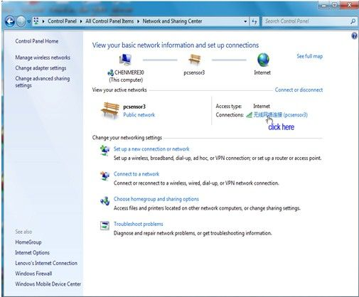
(1)
3.3.2 Click “Properties”
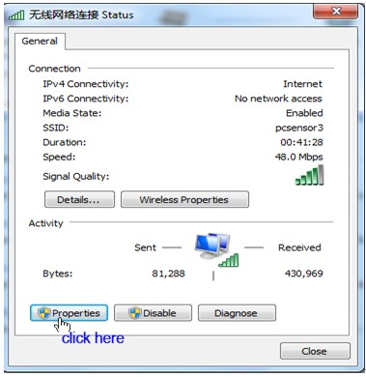
(2)
3.3.3 Double Click “Internet Protocol Version 4(TCP/IPv4)”
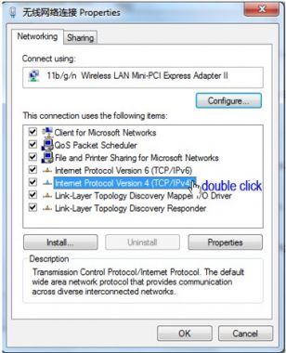
(3)
3.3.4 Click “Advanced”
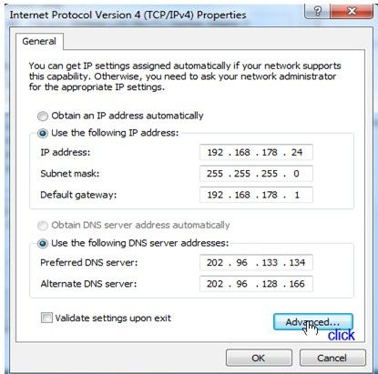
(4)
3.3.5 Click “Add”
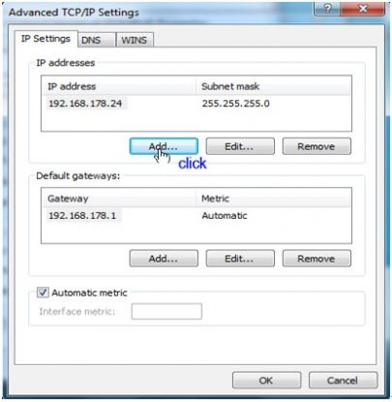
(5)
3.3.6 Add Our Default IP (As Follows)
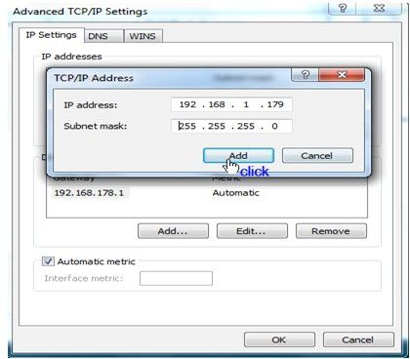
(6)
3.3.7 Click “OK”
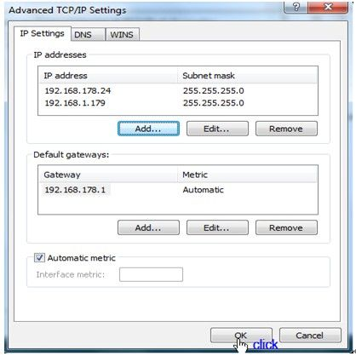
(7)
4.Software instructions
4.1. Search probe
Open software will appear the following window, fill in equipment starting the IP address and ending IP address, then , software will search the device from starting to end the IP address .(including all the 1 W340 equipment )
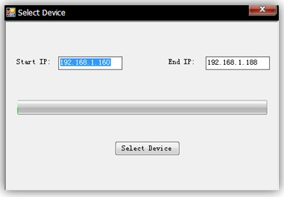
4.2. Real-time temperature
Click on "real-time data” and select IP address what you want to check the equipment. As follow:
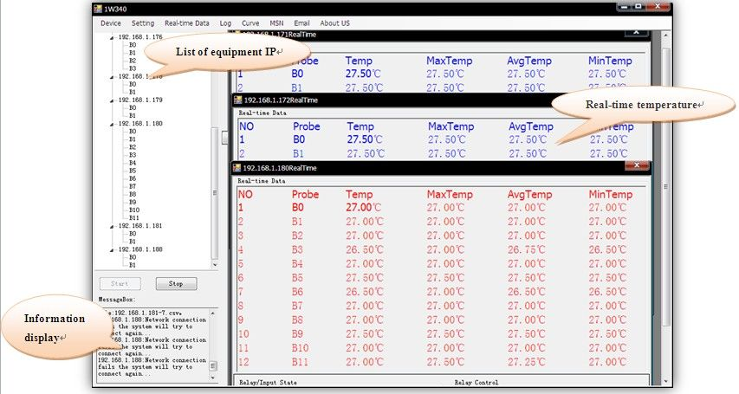
4.3. Log
Choose what you want to see the equipment IP address and read the temperature (As follows). log default save directory: my document \ PCsensor \ 1 W340 V1.0 \ Data
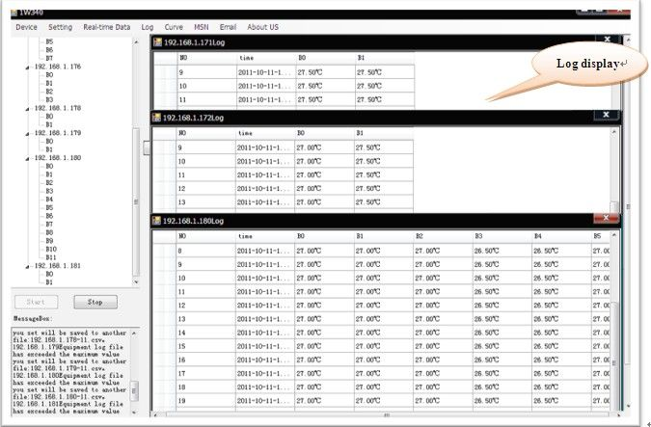
4.4. Curve
Choose what you want to see the equipment IP address
Click left mouse button under marquee can zoom curve and narrow curve; Click and hold the right mouse button, can move the curve.
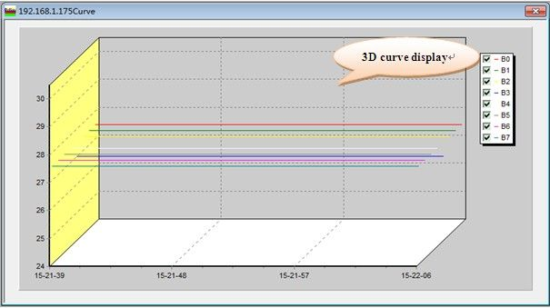
4.5. Setting
Click on “Setting” and select “General Setting “. As follows:
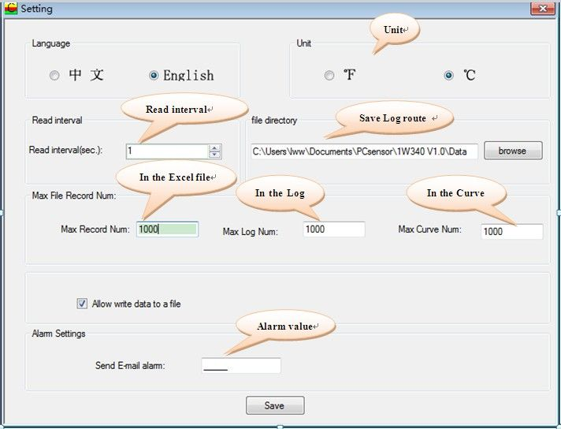
Click"Setting" and choose "Device Setting" , choose one IP address, as follow：Click on “inner interface”, Go into the internal relay setting.
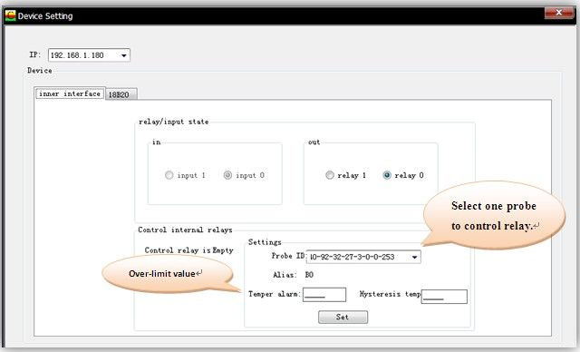
Click on the 18 b20, will enter DS18b20 temperature probe to set temperature calibration value.
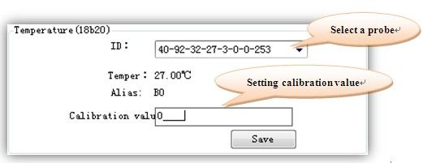
4.6. MSN remote access to the temperature
MSN users log in, your friends can send related instructions and to obtain the relevant temperature data. When your friends send prompted number 1 to you, he will automatically get the temperature data. Including: real-time temperature, maximum, minimum and average.
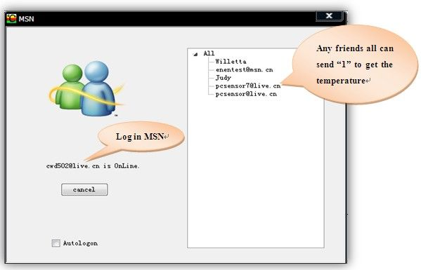
(1)
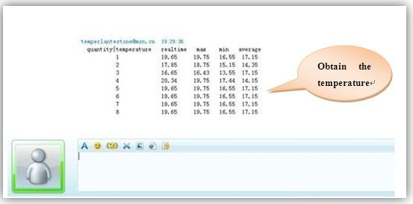
4.7. Email function
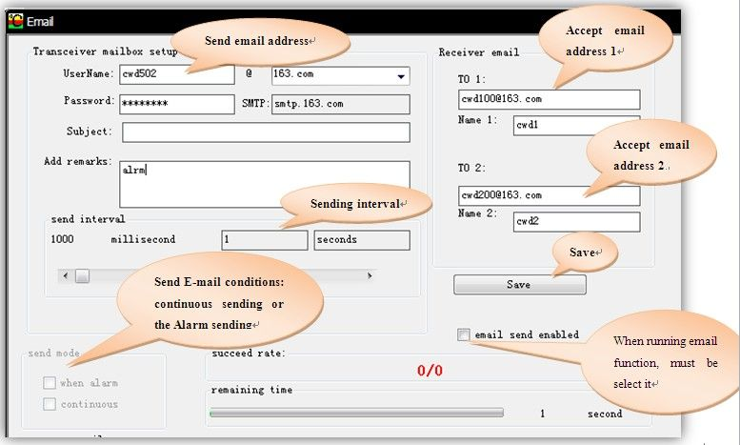
Fill-mail message, and save. (Send E-mail request: support for POP3/SMTP services or other ports.) Receiving mail can fill two.
Can realize the following functions:
1, open warning function, when the alarm is automatically triggered to send a message to the specified mailbox;
2, you can set the time, from time to time, it will send a message to the specified mailbox (recommended);
3, open continuous send, You can send mail to open a row in the specified mailbox (not recommended).
5.Pcaking list(not standard)
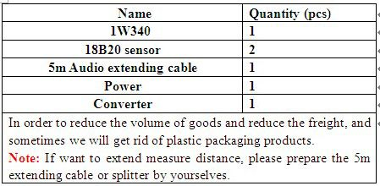
6.Product photos
(1)
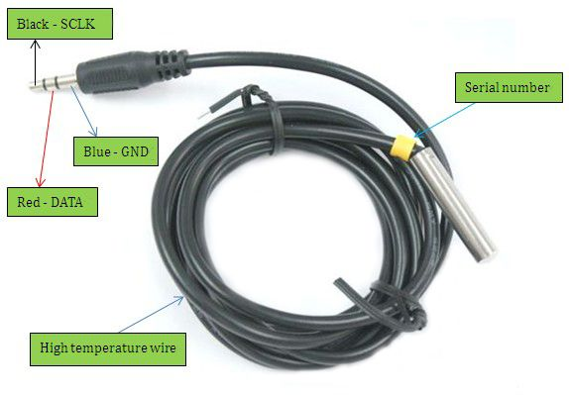
Tx sensor
(2)
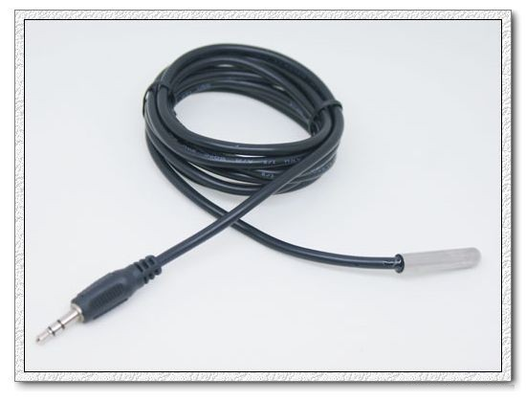
Dx sensor (18b20sensor)
(3)
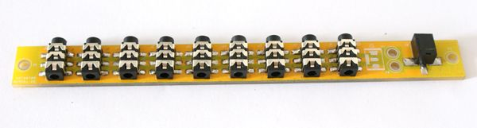
converter (option)
(4)
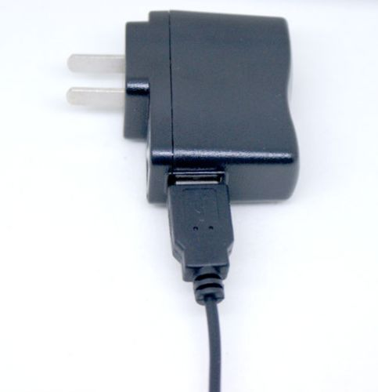
USB Power
(About the Power supply type , If you have special request , please let me know .)
(5)
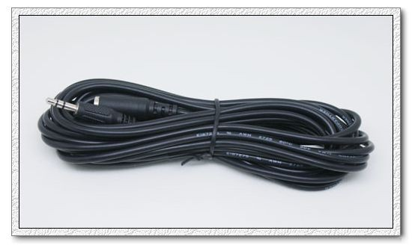
5m audio extending cable(option)
End

