PC Isolate Thermometer K Thermocouple Probe
1.Instruction
outer sensor K thermo-element , 2m length ,you can to change the thermocouple of outer sensor ;
2.Features
a)outer thermocouple range 0~ +1024℃
b) Resolution：0.25℃
c) Accuracy
i. 0~700℃： -2 ~ +2℃ ；
ii. 700~1000℃： -5℃~+5℃
d) Inner sensor (measure environment temperature ), -40~+120 Celsius ;
e) Thermocouple converter has isolation function . USB, and the probe part is isolated, isolation voltage of about> 1000V
f) The automatic transmission function . can use excel and Notepad to directly receive. "Start / stop" button can start or stop sending data automatically send the data, then open the excel ,word or Notepad, you can automatically record data to thees texts, in the recording process, press the keyboard "capslock "or "numlock" recording interval can be achieved Adjustment.
g) packing list :
1, Isolated thermocouple converter (plastics case) 1pcs;
2, K-type thermocouple (cable 2meters) , 1pcs ;
3, power Adapter (DC5_7V@500mA)
4, CD ;
h) Power: 3V~ 6VDC， power supply USB；
i) Current<10mA
k) Support winnt, WinXP , Win7, vista ;
3. Product photos

Picture 1
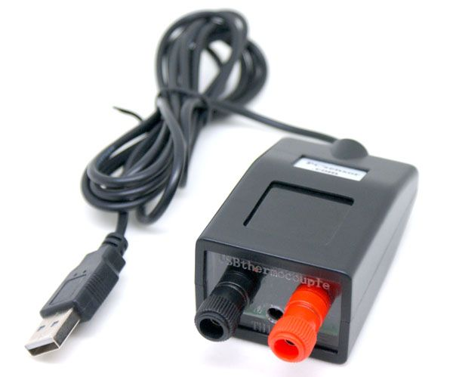

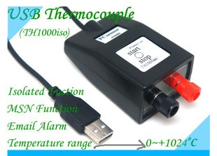
Picture 2
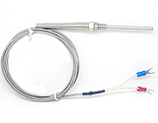
Picture 3
4.A pplication:
a)solder furnace and boiler temperature detection;
b) rice cookers, kitchen utensils, Induction Cooker, heater temperature detection;
c) The horse, reaches pipeline temperature measurements and so on compressor, steam
5. software
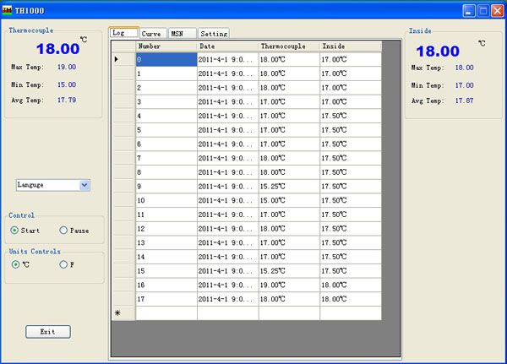
picture1 read temperature
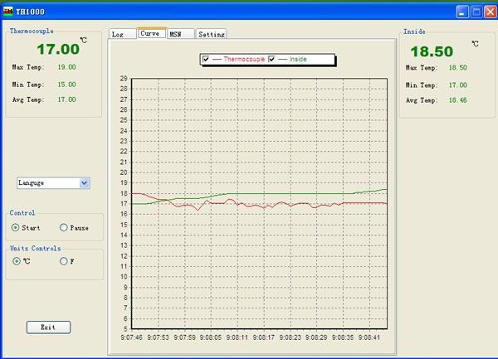
picture2 Curve
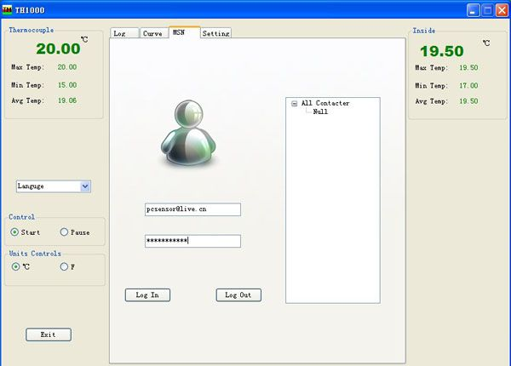
picture3 MSN_log in
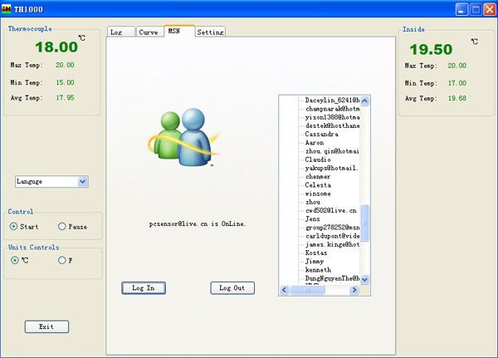
picture4 MSN_Successful
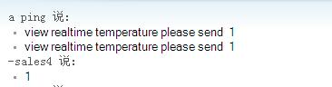
picture5 MSN_read data
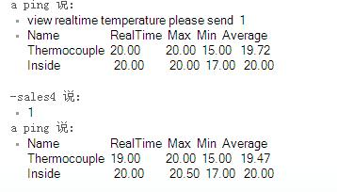
picture6 MSN_read data
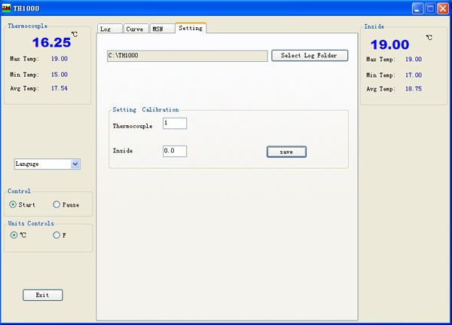
picture7

