Innovative創新技術
Solutions 解決疑難
Water淨水 • Wastewater廢水 • Biosolids有機物
淨水

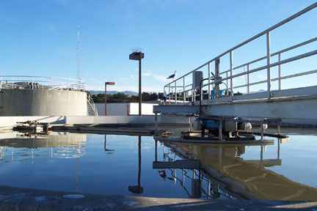

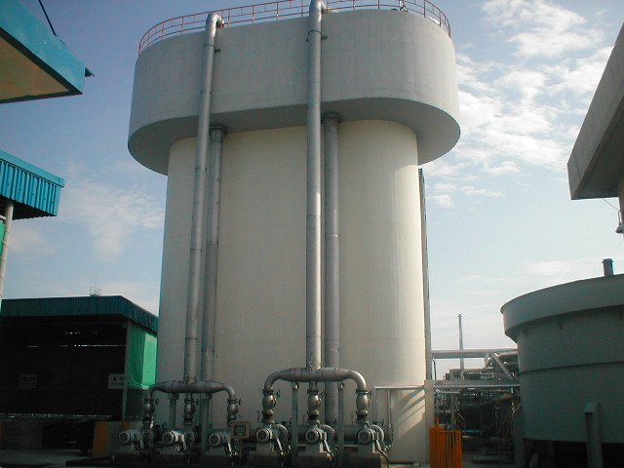

台灣 合保旺企業有限公司
德國 特科諾技術公司-水資技術與顧問專業

Water Technology • Consulting
TECHNOCON GmbH

About Us特科諾簡介

Company Profile公司資訊
特科諾技術公司為環保技術公司，提供創新技術最佳方案:
- 淨水處理
- 廢水處理
- 有機污泥處理

TECHNOCON GmbH is a German Environmental Engineering Company and provides “Optimal Solutions” with innovative technologies in the following fields:
- Water Treatment
- Wastewater Treatment
- Bio-sludge Treatment
本公司從事都市與工業廢水處理技術，從一級，二級及三級廢水處理系統尤其含污泥處理，本公司擁有國際專利來應用於高效能精簡有機反應槽及超量污泥減量工藝。
We specialize for more than 20 years in the municipal- and industrial wastewater treatment with excellent experience in primary, secondary and tertiary wastewater treatment systems as well as sludge treatment. In particular, we hold the international patents for the High-performance Compact Bioreactors and the Excess Sludge Reduction Process.
提供下列服務範疇
Our services include:

- Management of Wastewater Treatment Plants廢水處理廠管理
- Consulting for Operation of Plants and Systems廢水廠操作咨詢顧問
- Technical Evaluation/Expert Opinion技術評估及專業意見
- Pilot Plant Studies/ Plant Optimization實驗工廠研習及最佳化處理廠
- Research and Development (R&D)研究與發展
- Basic Engineering基本設計

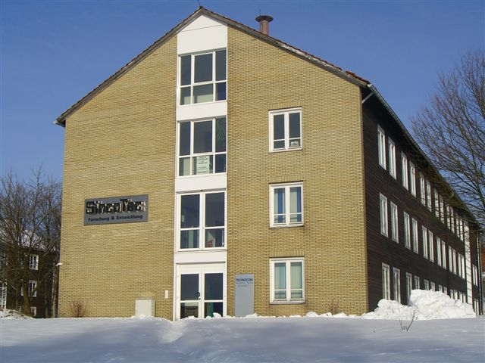
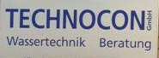

聯絡地址與電話
Albrecht-von-Groddeck-Str. 5 D-38678 Clausthal-Zellerfeld | Tel. : ++49 5323 9629081  Fax : ++49 5323 9629080 | 合保旺公司-台中市工業區一路58巷10弄35號7C  Tel: +886-4-23553377  Fax: +886-4-23553379
E- mail : info@technocon.de |  | 電子郵件:hbw.corp@msa.hinet.net
Fields of Activity業務範疇
特科諾技術公司提供工程服務基於發展理念來建造及操作淨水及廢水處理設施
TECHNOCON offers engineering services from the development of first concepts to construction and operation of water and wastewater treatment facilities.
我們專精於下列項目:
We are specialists in:
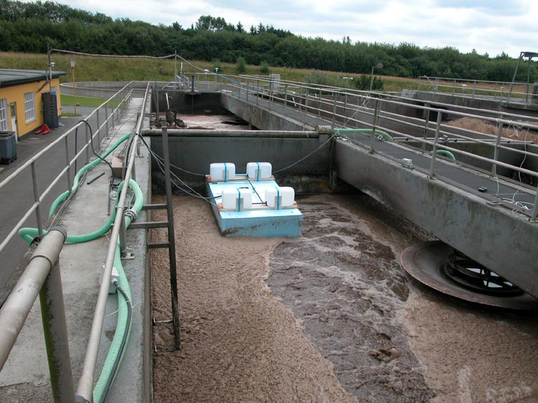
● Municipal Wastewater Treatment都市廢水處理
中小型廠之管理
針對既有廢水廠對成本及操作作最佳化
新觀念以物理機械生物及化學處理廢水
減量污泥生產與處理
- Management of small and medium sized plants
- Optimization of existing plants regarding costs and operation
- New concepts for physical, mechanical, biological and chemical wastewater treatment
- Reduction of sludge production and treatment

Optimization of a WWTP廢水廠最佳化

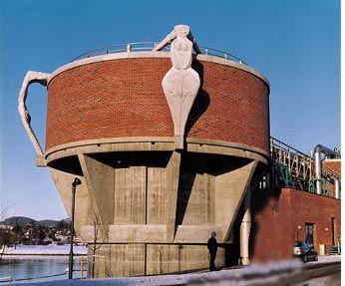
● Industrial Wastewater Treatment工業廢水處理
- Innovative concepts for pretreatment, treatment and reuse創新觀念之前後處理及再利用回收
- Anaerobic and aerobic high performance biological wastewater treatment technologies (e. g. membrane bioreactor)厭氧喜氧高效能生物處理技術及薄膜生物槽
- Advanced Oxidation Technologies高級氧化技術
- Consulting for optimized operation, simulation and maintenance最佳操作模擬及維護之顧問

Pulp wastewater treatment by CLR
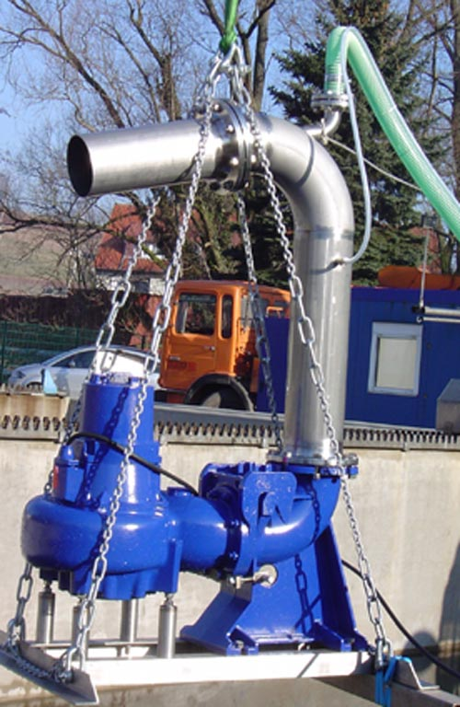
● Research研究
- Development of Bio-Reactors生物床開發
- Methods of Excess Sludge Reduction減污泥方法
- Methods of Sludge Conditioning污泥調整方法
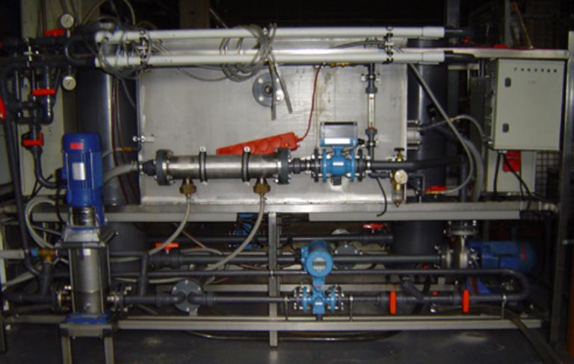

MBR Pilot Plant 薄膜試驗廠 Nozzle Aerator曝氣噴射機
Management & Consulting管理與諮商

Management of wastewater treatment plants廢水廠管理

Sewage charges increase constantly and are varying largely. 污水排放量差異大

TECHNOCONs more than 20 years experience in wastewater treatment was the basis for starting management and consulting activities for small and medium sized wastewater treatment facilities. The first long term contract for the management of a municipal wastewater treatment plant was signed in 2002. The advantages in combining the technological with the business-management expertise are:
本公司累積廢水處理超過20年經驗，此為邁入顧問與諮詢中小型廢水處理之基礎。第一套都市廢水處理操作合約於2002簽訂，展現技術與商業經營結合之優勢:
Advantages
- Reduction in sewage charge without privatization
- Safety in long term planning
- Cost reduction due to centralized and cost efficient purchase, optimized process control (energy) and excess sludge utilization
- Improvement in operating safety by application of simulation tools, optimized process control, and a far reaching emergency program
- Public relations and presentations in communal panels。
- Training and further education of the operating personne
- Provisioning of a water pollution control commissioner on request
- 優勢
- 無需經由私有化，即減少公用污水排放。
- 長期規劃安全運轉。
- 集中節約效率採購節省成本，最佳操控過量污泥。
- 應用模擬工具最佳操控及避險程序，達成安全運轉。
- 公關與鄉鎮社區溝通。
- l操作員訓練及再教育。
- 提供水污染控制督導專家!
Our Technologies擁有的技術

High-Performance Compact Bioreactors高效能套裝生物反應槽
特科諾技術公司具備高效能生物槽之廣泛經驗，稱為CLR 及CJR工藝，本公司擁有全世界專利權，涵蓋廢水處理設計及操作技術。目前全球有大約50座操作中的不同廢水處理廠 (化學，食品，漿紙廠，屠宰場排水，填土滲出液，豬舍水肥)。
TECHNOCON has an extensive experience with high performance biological treatment processes, called CLR (Clausthal Loop Reactor)-Process and CJR (Clausthal Jet Reactor)-Process. We hold the international patents and its design and operation know-how for wastewater treatment. Now full scale plants (about 50 plants) are operating for treatment of different wastewaters (chemical, food, pulp and paper industry, slaughter house effluents, landfill leachates, night soil of pig farms etc.) worldwide.
Advantages of high-performance compact bioreactors
- High performance with highly active bacteria (VSS up to 20 g/l)
- Small reactor volume (volumetric loading up to 40 kg COD/m³d)
- Simple and compact construction
- High oxygen transfer rate (up to 3 kg/m³d)
- Semi-permanent use of two-phase jet nozzle
- Fast adaptation of microorganisms to wastewater fluctuations
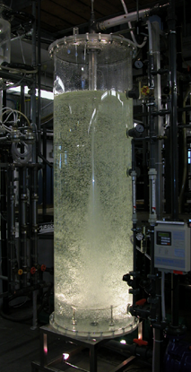

CJR
高效能生物反應槽之優勢
高效能及高活力細菌(VSS揮發懸浮污泥達20 g/l))
生物反應槽小體積(負荷體積達40 kg COD/m3-d)
簡單及套裝構造。
高氧傳輸，達到 3kg/m3-d.
半永久使用兩相噴射噴嘴。
快速適用
Reduction of Excess Sludge Production
減少過量污泥的產生
TECHNOCON has a Technology for the Reduction of Excess Sludge Production in biological wastewater treatment plants by the addition of VITA 99. International patents for this technology are applied for in 27 countries (EU, USA, Japan, China, Korea, Australia, Canada etc.).
特科諾技術公司俱備減少污泥技術使用在生物廢水處理場，添加國際專利之VITA 99, 應用27國家(歐洲，日本，美國，中國，韓國，澳洲，加拿大等等)
● Application Results:
Several municipal WWTPs, Germany (average 50 % reduction of excess sludge production)
多間都市廢水處理場，在德國(約平均減少50%污泥生產)。
- Reduction of excess sludge production (up to 60% ) due to a faster metabolism, a higher activity of microorganisms and a limitation of the simultaneous cell division
- No constructional change of treatment plant and no investment costs required
- Improved sludge characteristics and process stability
- Improvement of effluent water quality (COD < 20 mg/L)
- Decrease of sludge treatment costs by reduction of polymer addition
˙應用結果:
- 減少過量污染約達 60%，歸功於較快新陳代謝，較活性的微生物及限制同一時細胞分裂。
˙水處理場無需建築變更，也沒有投資成本!
˙改善污泥特性及製程穩定。
˙改善排放水品質(COD < 20 mg/L)
˙經由減低聚合物添加，以降低污泥處理成本。
合保旺企業有限公司公司
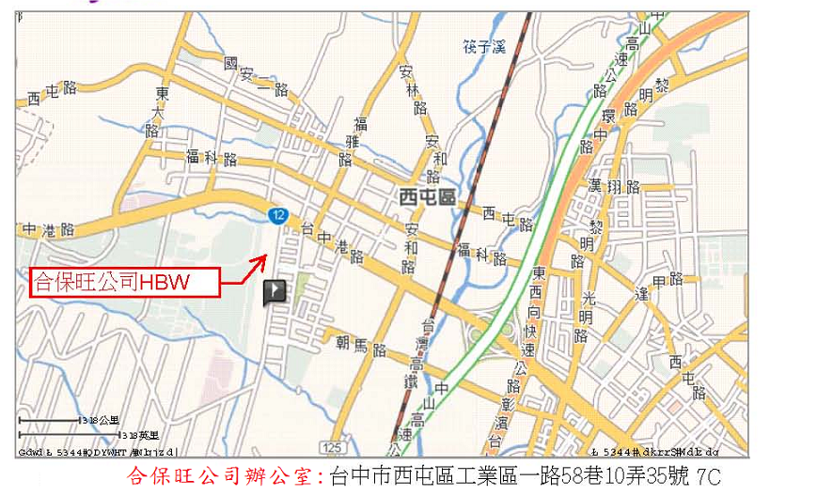
Tel: 04-23553377, Fax: 04-23553379, E-mail: hbw.corp@msa.hinet.net, www.hbwcorp.com.tw
Contacts接洽人員

Postal Address 郵政地址 Telephone & Fax電話/傳真
TECHNOCON GmbH
Albrecht-von-Groddeck-Str. 5
D-38678 Clausthal-Zellerfeld
Germany
Tel. : ++49 5323 962 9081
Fax : ++49 5323 962 9080
Contact : Dr.-Ing. M. Nagel
(nagel@technocon.de)
E-mail & Web電子郵件
info@technocon.de www.technocon.de
Location Plan
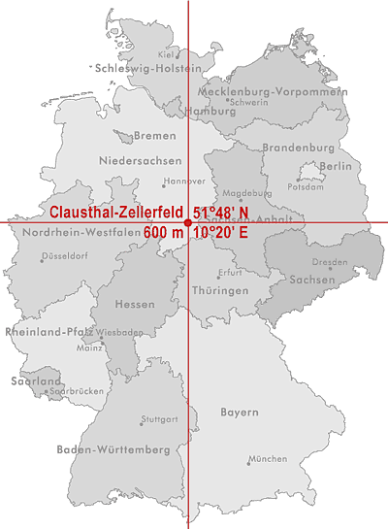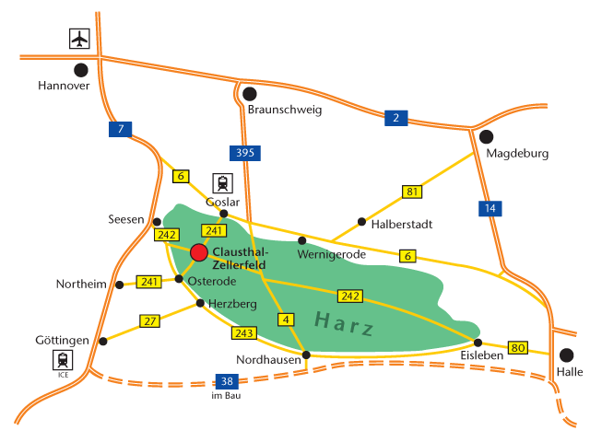

Travel Information旅行資訊
By car: 搭車
From Hanover and Kassel: Highway A7 to exit Seesen; Bundesstrasse (A-road) B243 direction Osterode; after approx. 5 km Bundesstrasse (A-road) B242 to Clausthal-Zellerfeld.
From Berlin: Highway A2 to Kreuz Braunschweig-Nord; highway A391 to Dreieck BS-Südwest, from here direction Bad Harzburg; highway A395 to Bad Harzburger Dreieck; Bundesstrasse (A-road) B6 direction Goslar; from Goslar Bundesstrasse (A-road) B241 to Clausthal-Zellerfeld.
By airplane: 坐飛機
The nearest international airport is Hanover, approx. 100 km from Clausthal-Zellerfeld.

